# Question 8: Finding an Inverse Modulo *n*

# Introduction about Extended Euclidean Algorithm

## Extended Euclidean Algorithm

The extended Euclidean algorithm not only computes the GCD but also finds integers x and y such that ax + by = gcd(a, b). This is an extension of the basic Euclidean algorithm.

### Example

Suppose you want to find the GCD of 120 and 23, and also find integers x and y so that

120x + 23y = gcd (120, 23):

Apply the Euclidean algorithm to 120 and 23:

- 120 % 23 = 8 (120 - 5 * 23 = 8)

- 23 % 8 = 7 (23 - 2 * 8 = 7)

- 8 % 7 = 1 (8 - 7 = 1)

- 7 % 1 = 0 (Ends here, GCD is 1)

Now, we backtrack through the steps to find x and y:

- 1 = 8 - 7

- 1 = 8 - (23 - 2 * 8) = 3 * 8 - 23

- 1 = 3 * (120 - 5 * 23) - 23 = 3 * 120 - 16 * 23

Thus, x = 3 and y = −16y are the integers found.

# Introduction about Inverse Modul

In modular arithmetic, there is no traditional division operation. Instead, we have the concept of **modular inverses**. The modular inverse of a number A modulo C is a number $A^{-1}$ such that $a×a^{-1}≡1$ (mod n).

In other words, that $a×a^{-1}=1$ mod n = 1. This means that if gcd(a,n) ≠ 1, then A does not have a modular inverse. Only numbers that share no common factors with n (i.e., their greatest common divisor with n is 1) have a modular inverse modulo n.

**Example to illustrate:** Let's take n = 14. We know that 14 is the product of the prime numbers 2 and 7. According to the definition, numbers that share no common factors with 14 are those not divisible by 2 or 7.

**Method for finding a modular inverse using the extended Euclidean algorithm:**

1. Use the Euclidean algorithm to find gcd(a,b)
2. Write down the equation ax + by = gcd (a,b) and solve for x and y.
3. If gcd (a,b) = 1, then x is the inverse of a modulo b. If x is negative, add b to it until you get a positive value.

**Example:** Choose the number 3 to check if it has an inverse modulo 14 and then calculate the modular inverse if it exists.

First, we need to calculate its gcd with 14 using the extended Euclidean algorithm:

* 14=4×3+2
* 3=1×2+1
* 2=2×1+0
* gcd(3,14)=1

Since gcd (3,14) =1, 3 has a modular inverse modulo 14.

Next, solve for x and y in the equation 3x + 14y = 1

* 1=3×(−4)+14

So, x=−4. Add 14 to get a positive value:

* x=−4+14=10

Therefore, the inverse of 3 modulo 14 is 10 because 3×10 ≡ 30 ≡ 1 (mod14)

**Python implementation :**

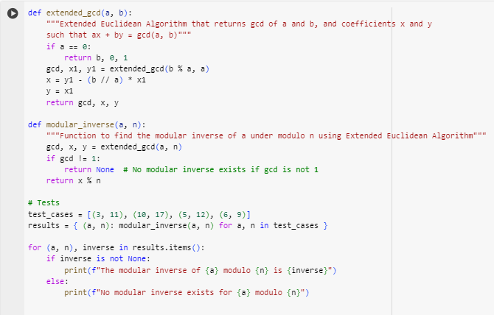

**Result :**

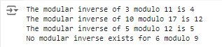

**Explanation of python implementation**

1. Extension function_gcd(a, b)

This function implements the Extended Euclidean Algorithm, used to find the greatest common divisor (gcd). And also determine the integers x and y such that ax + by = gcd(a, b).

• Base case: If a is 0 then gcd is b, respectively x = 0 and y = 1 are instantaneous solutions.

• Recursive: If a is non-zero, the algorithm calculates gcd(b % a, a) and then uses the result from the recursive call to calculate x and y for the current step.

* x is updated according to the formula: x = y1 - (b // a) * x1.
* y is taken directly from x1 from the previous recursive call.

2. Function module_inverse(a, n)

This function finds the modular inverse of the modulus below n using the Extended Euclidean Algorithm. The modular inverse of a is a number x such that (a * x) % n = 1.

• Check gcd: Initially calculate gcd(a, n). If gcd is not equal to 1, then the modular inverse does not exist because a and n are not coprime.

• Calculate the inverse: If gcd = 1, use the x value from extend_gcd to determine x %n, this is the modulus inverse to find.

* The modular_inverse function returns the modular inverse if it exists, and returns None if it does not exist.